Machine Learning: Field of study that gives computers the ability to learn without being explicitly programmed.

Types:

* Supervised Learning
* Unsupervised Learning
  + Recommender Systems
  + Reinforcement Learnings

**Supervised Learning:**

Input to Output mapping, give your learning algorithm examples to learn from.

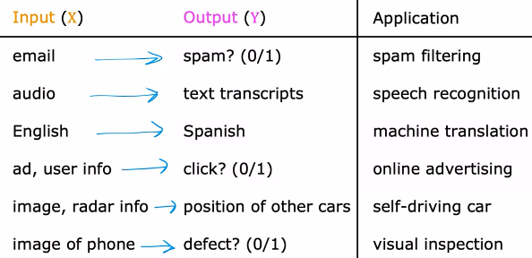

Types of Supervised Learning:

* Regression: We try to predict a number from infinitely many possible numbers
* Classification: We try to find

Breast Cancer Detection Example:

Predict if a tumor (lump) is malignant (cancerous), or benign (not cancerous), based on input: Size of the tumor

This is different from regression, as in regression we try to predict any number of all the infinitely many possibilities, but here, there are only 2 possible outputs, so it is classification.

In classification: class & category are used interchangeably, and categories don’t have to be numbers, it could be non numeric. When interpreting the numbers, what makes classification different from regression is that classification predicts a small, finite, limited sets of possible output categories such as 0,1,2 etc but not all possible numbers in between like 0.5 or 1.7.

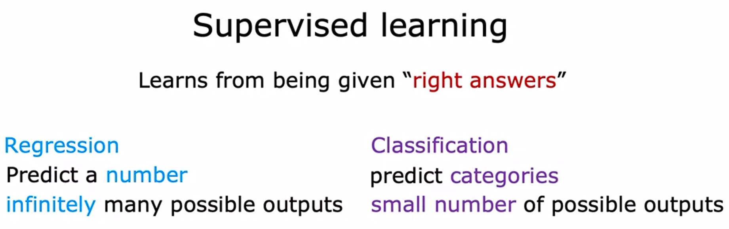

**Unsupervised Learning:**

Job is to find some structure/pattern in unlabeled data.

For example: Clustering is used in Google News, to group related stories together. Or Clustering similar people together based on similar DNA.

* Anomaly Detection: Find unusual datapoints, helps in fraud detection.
* Dimensionality Reduction: Take a big dataset and compress it to much smaller dataset while losing as less info as possible.

**Jupyter Notebook:**

Default environment for write codes and experiment new things out.

f strings allow you to embed variables right in the strings.

The content between the curly braces is evaluated when producing the output.

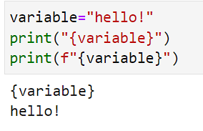

**Linear Regression Model:**

Supervised Learning, Fitting data into straight line.

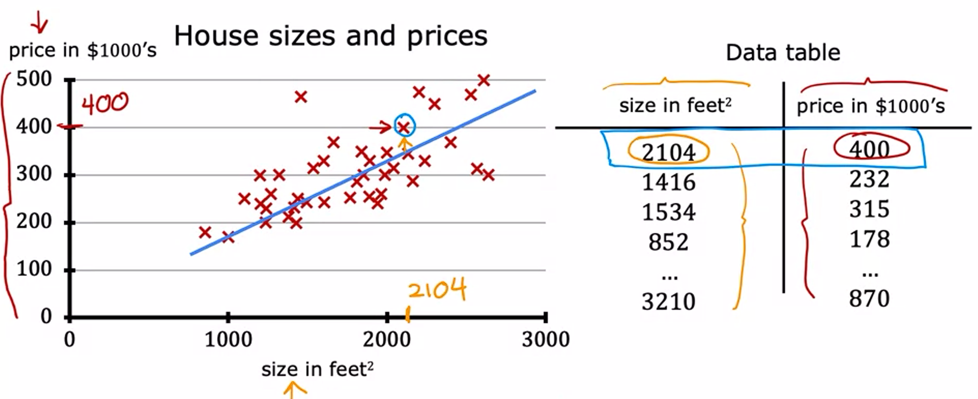

Here, both X and Y are given for datapoints, which are examined (supervised) to create one straight line that predicts values at infinitely many points (regression)

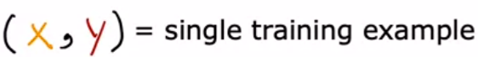**Terminologies:**

Training set: Data used to train the model.

x= input variable/feature/input feature

y= output variable/target variable

m= total number of training examples

(x,y)= single training example

**General Supervised Learning Algorithm:**

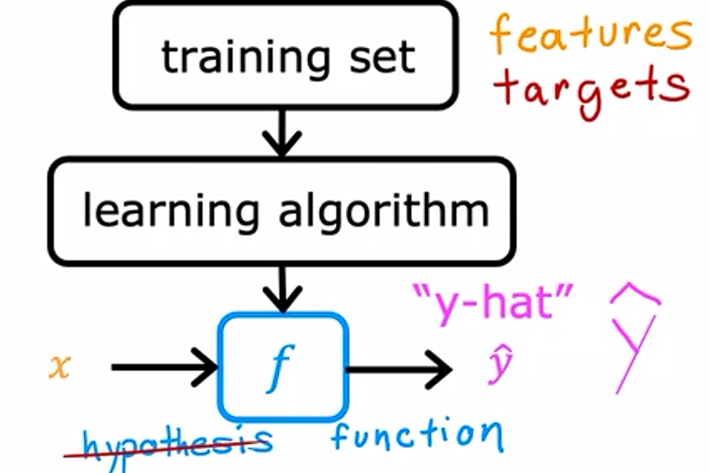

Historically f is called hypothesis, but we here just call it a function.

The function f is called the model, x is the input feature, and y-hat is the output of the model (prediction)

y-hat is the estimation/prediction for y (actual value)

**Linear Regression with One Variable:**

It is also called Univariate Linear Regression.

We choose the function: fw,b(x(i))= wx(i)+b

Here, w, b are parameters of the model/ coefficients/ weights

**Example:**

To fit a linear regression model through 2 given points:

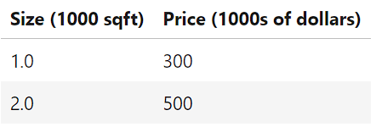

**Code**

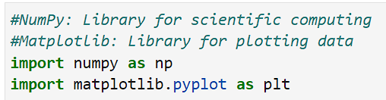

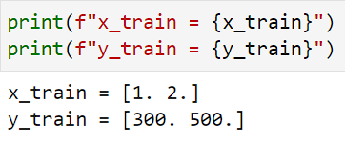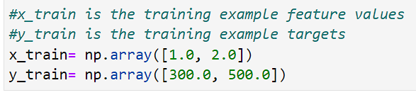

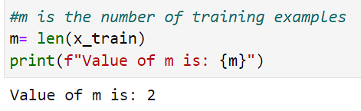

----------------------------------------------------------------------------------------------------------------------------------------------------------------

**Note:**

Better way for calculating value of m

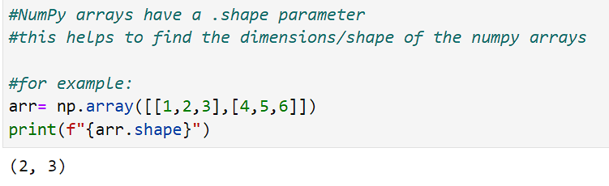

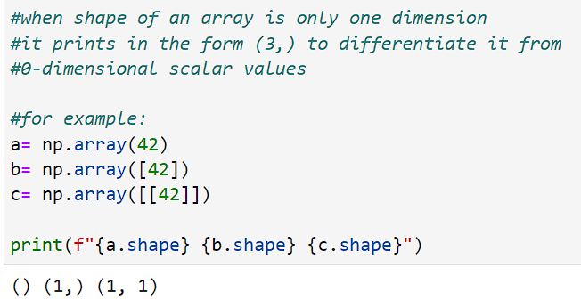

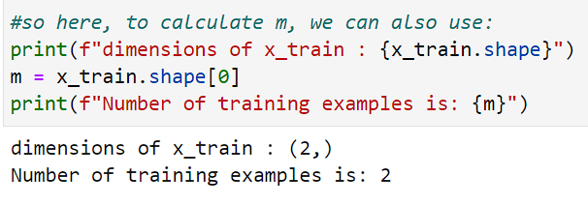

----------------------------------------------------------------------------------------------------------------------------------------------------------------

Here: we use (x_i , y_i) to denote (x(i),y(i))

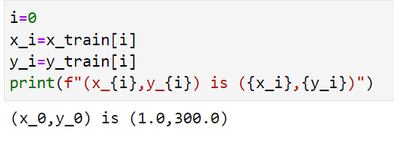 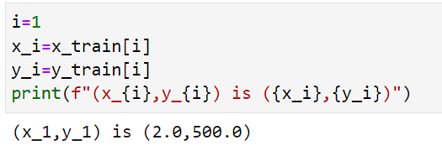

Using scatter() function of matplotlib

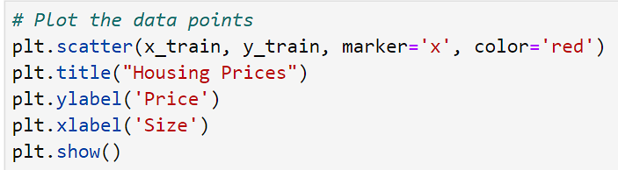

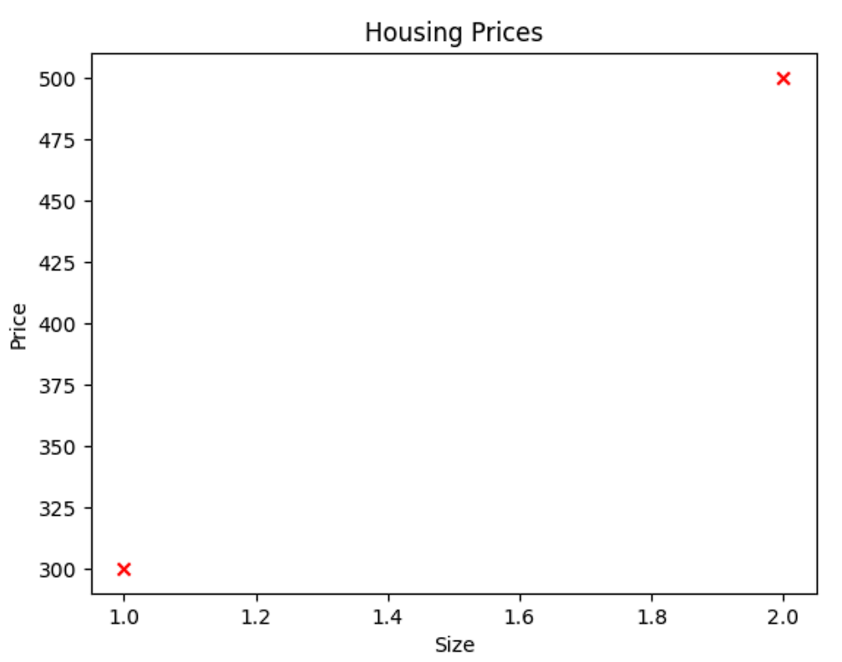

Defining w,b:

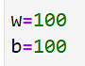

Creating python function to calculate values of f_wb for each i:

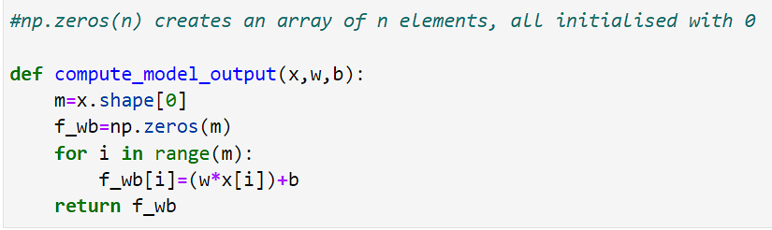

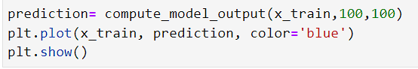

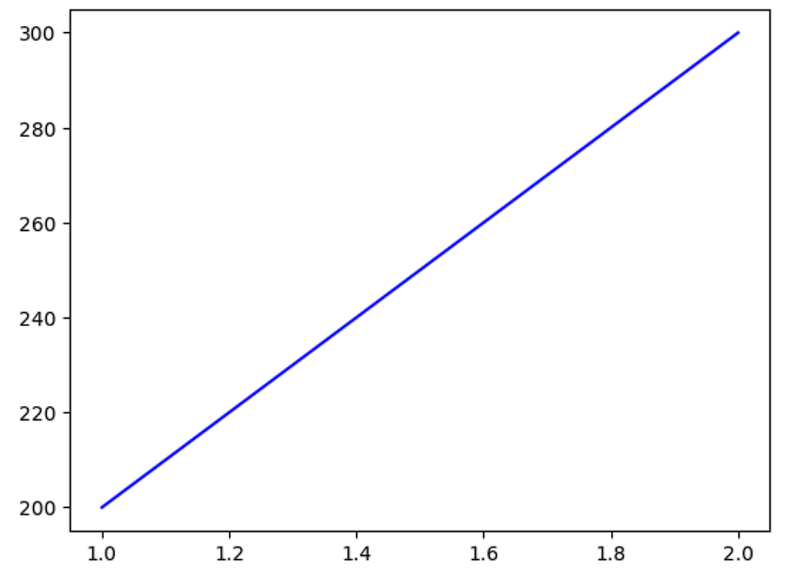

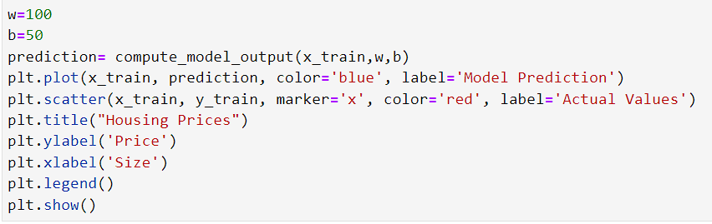

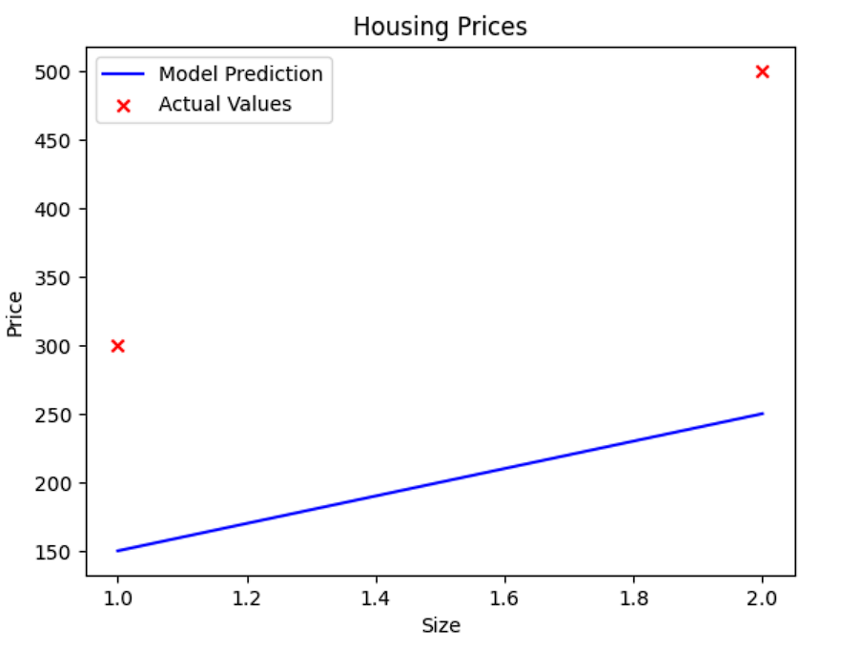

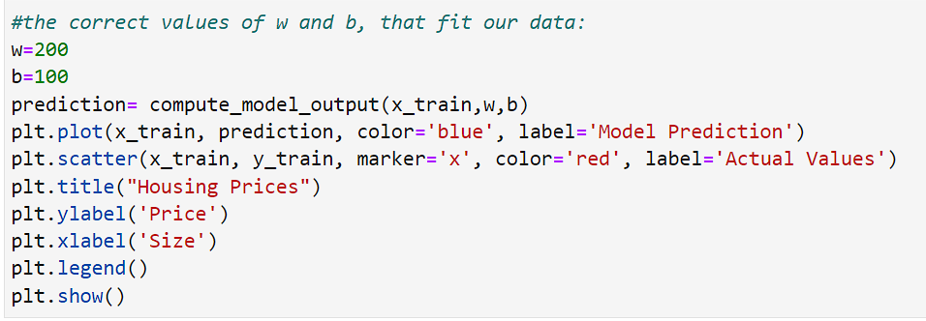

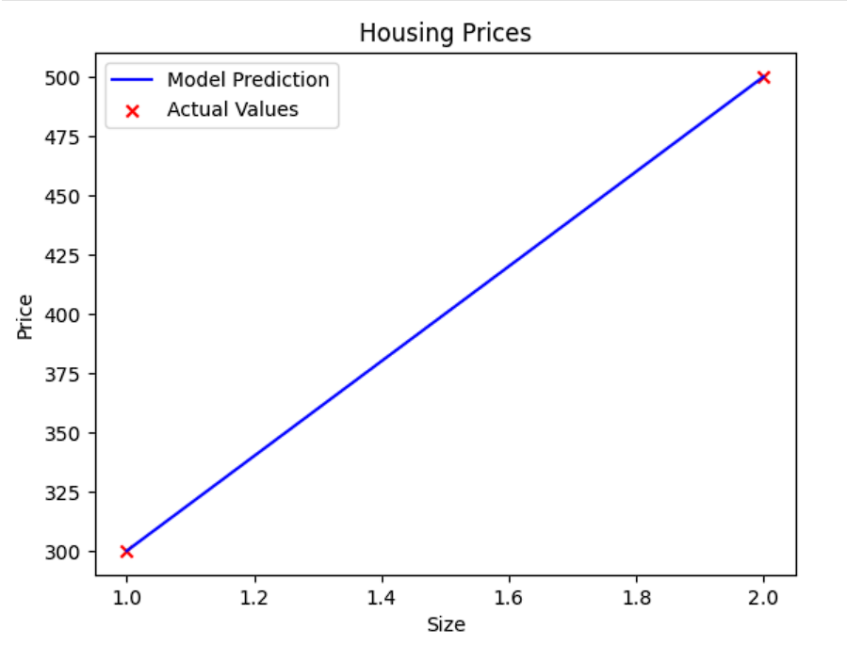

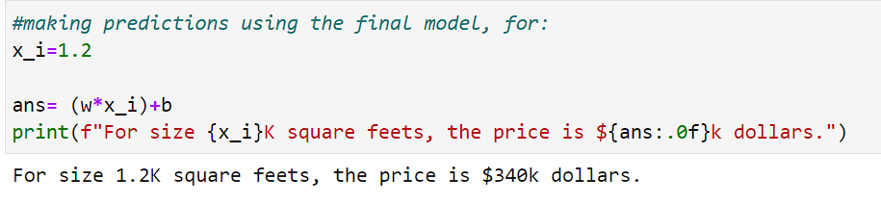

**Cost Function**

Calculates how well the model is doing.

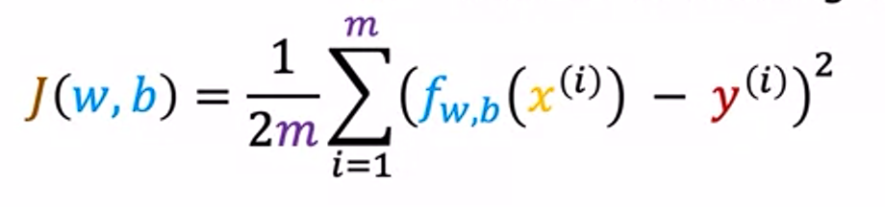

Here fw,b(x(i)) is the predicted value by model, while y(i) is the actual value. We calculate the Average sum of square of error, so it is also called squared error cost function. Note that we divide by 2m instead of m.

Goal is to find w,b so that J is minimum.

**Visualization:**

When we plot values w,b,J in 3-dimensions, we get a plot like: 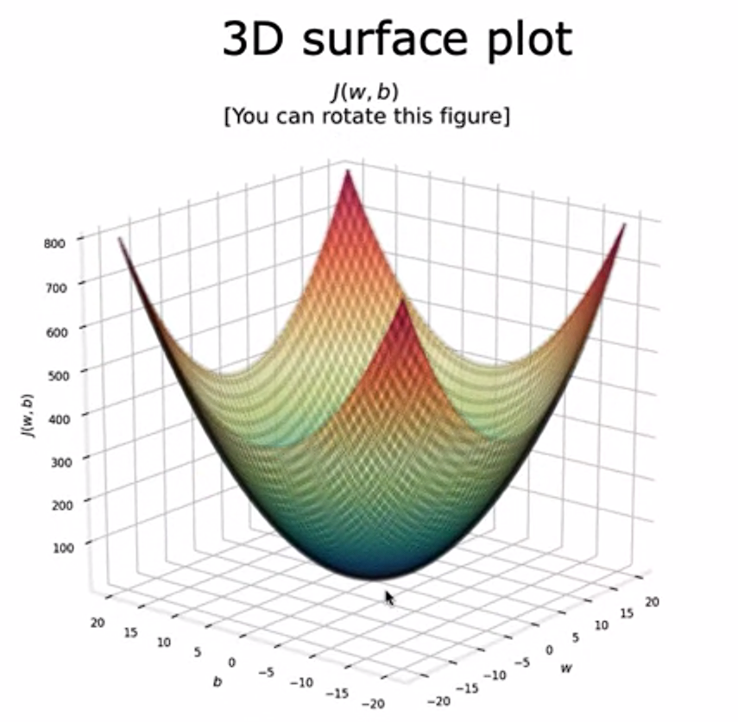

Here w,b are x and y axis while J is z axis. So, values at same height (same z) have same J values.

We use contour plot to analyze it. Slice values at same height. Kind of like:

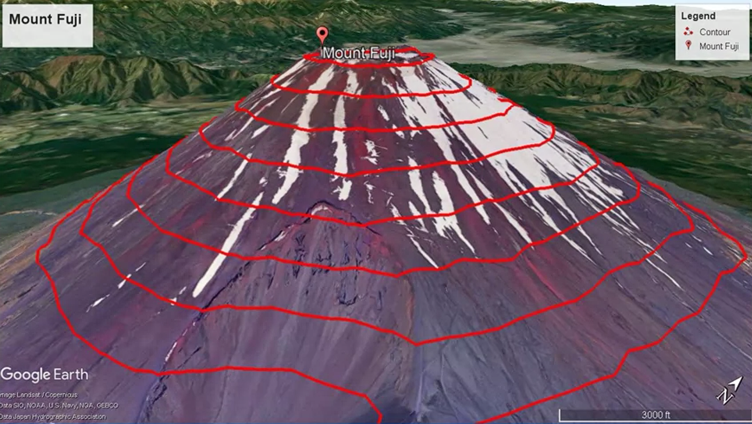

On slicing the 3d plot, we get something like this:

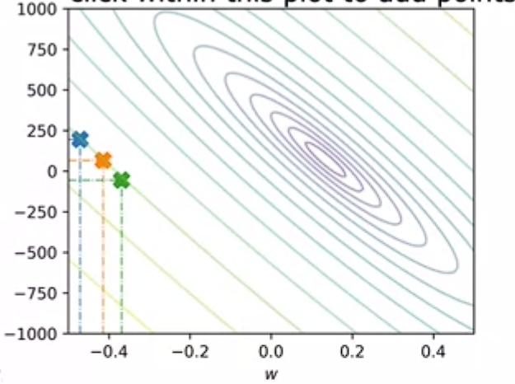

Values on the same circle (the 3 x) have same J. As circles/ovals become smaller, the value of J decreases. The Smallest circle (converges to a single point) has the minimum value of J.

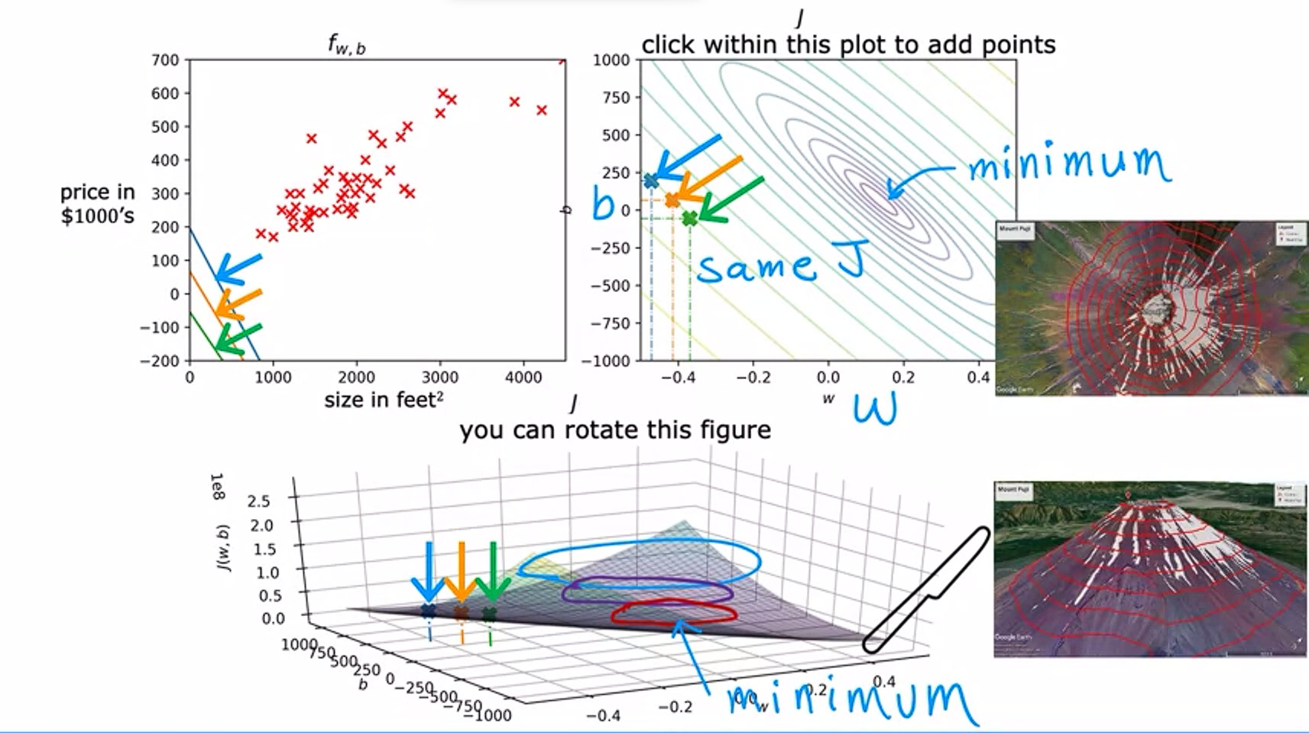

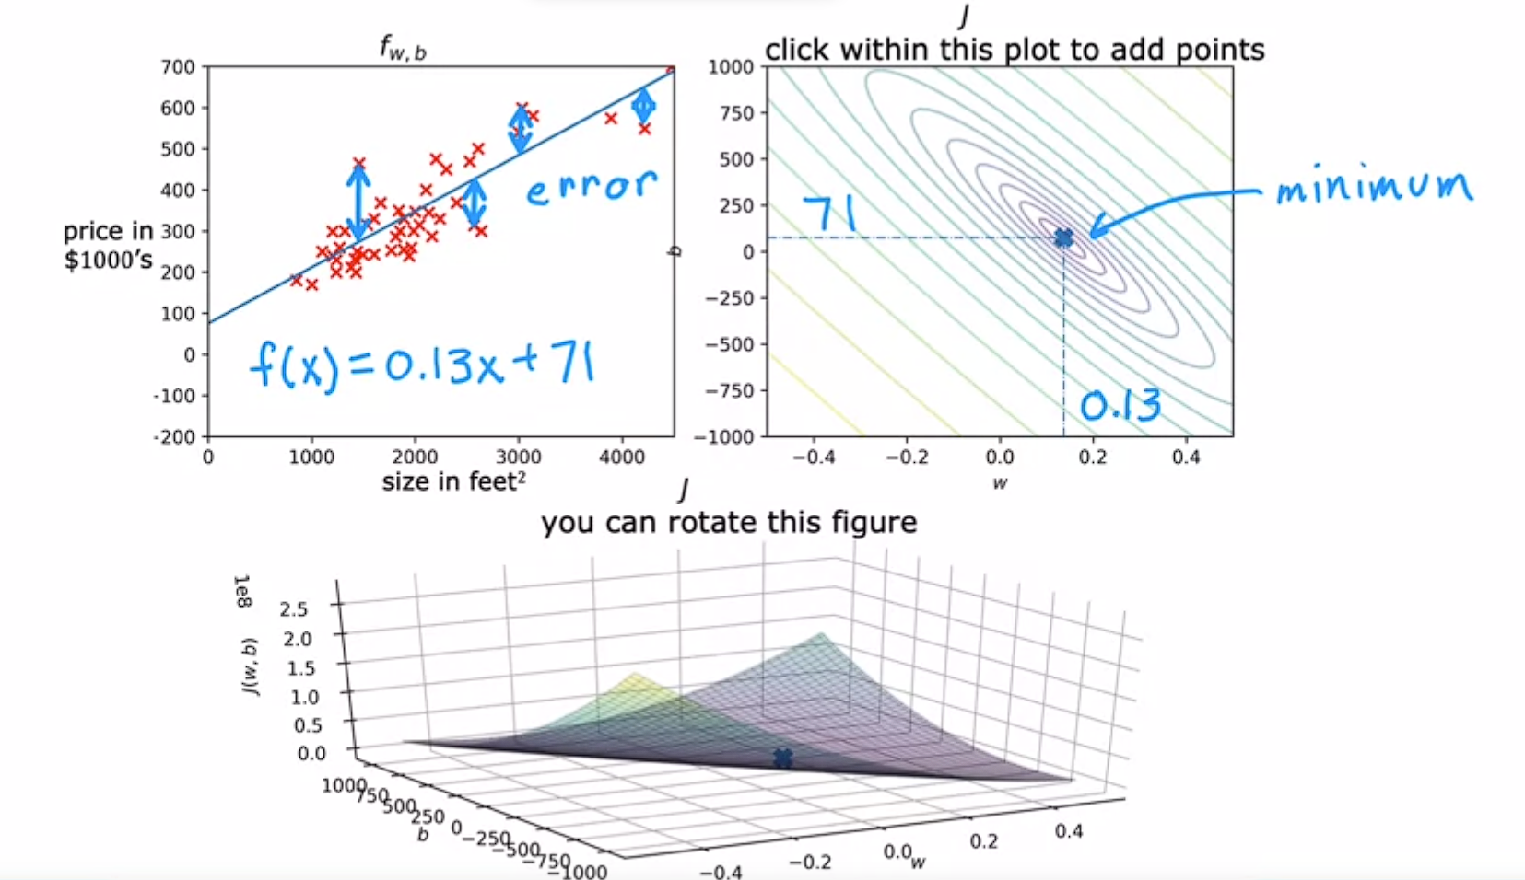

We use gradient descent algorithm to find the values of w,b that correspond to the minimum J.

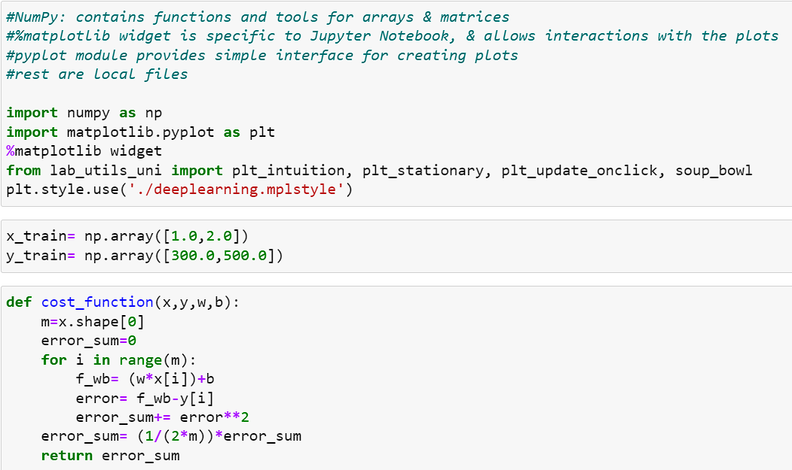

Fix b=100 and calculate J (cost function) for different values of w

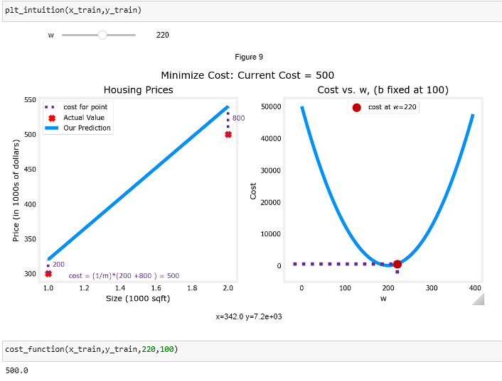

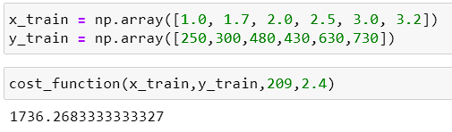

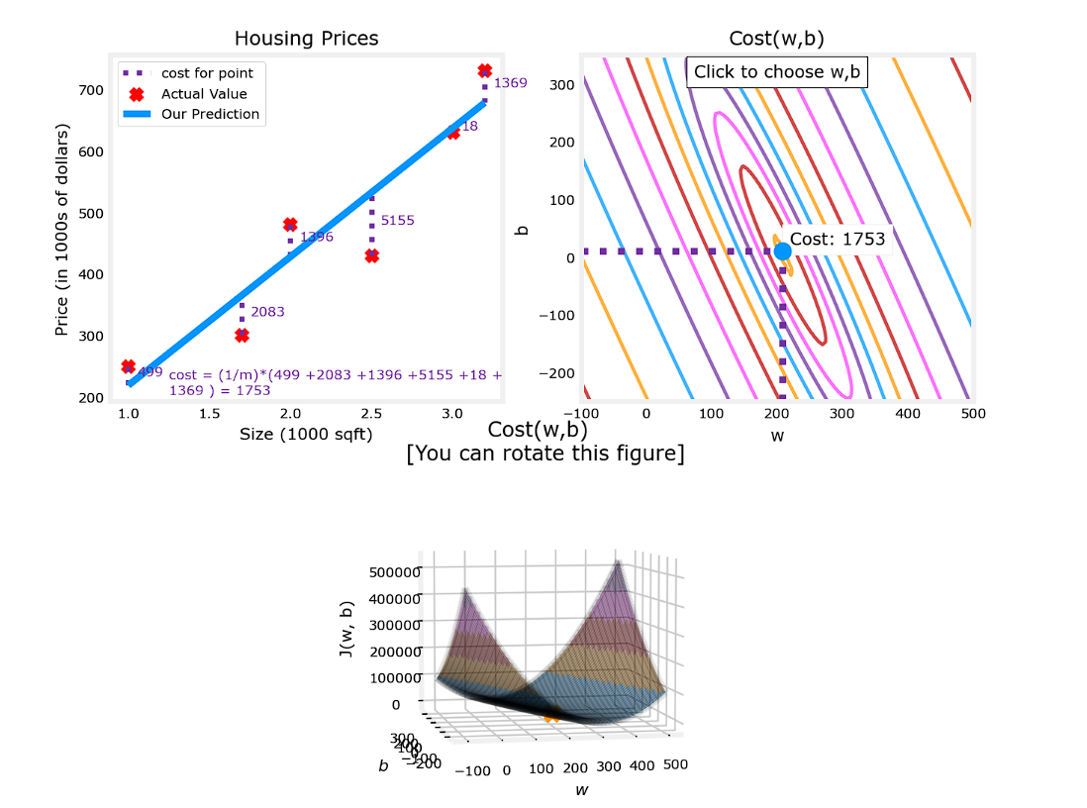

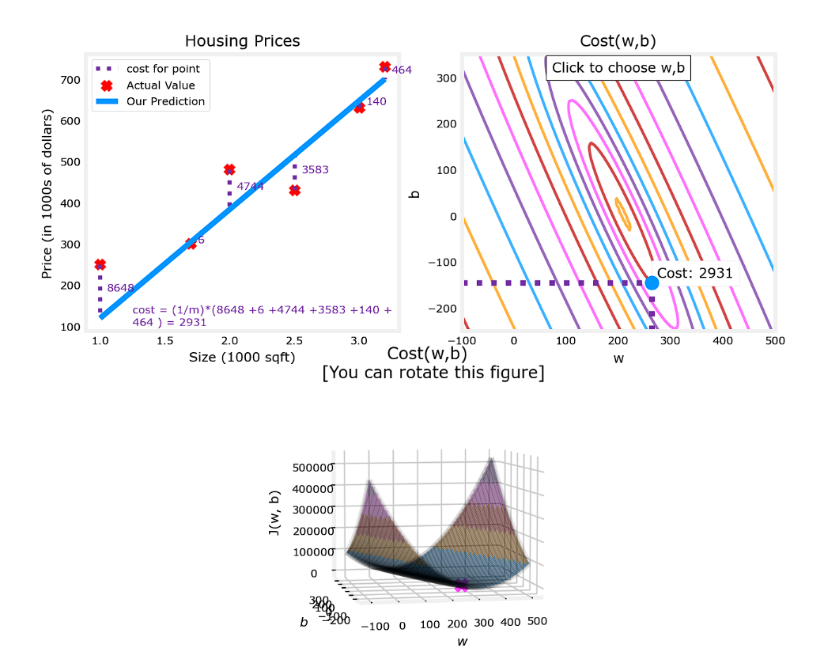

Gradient descent leads to local minima, and changing initial position can change final position.

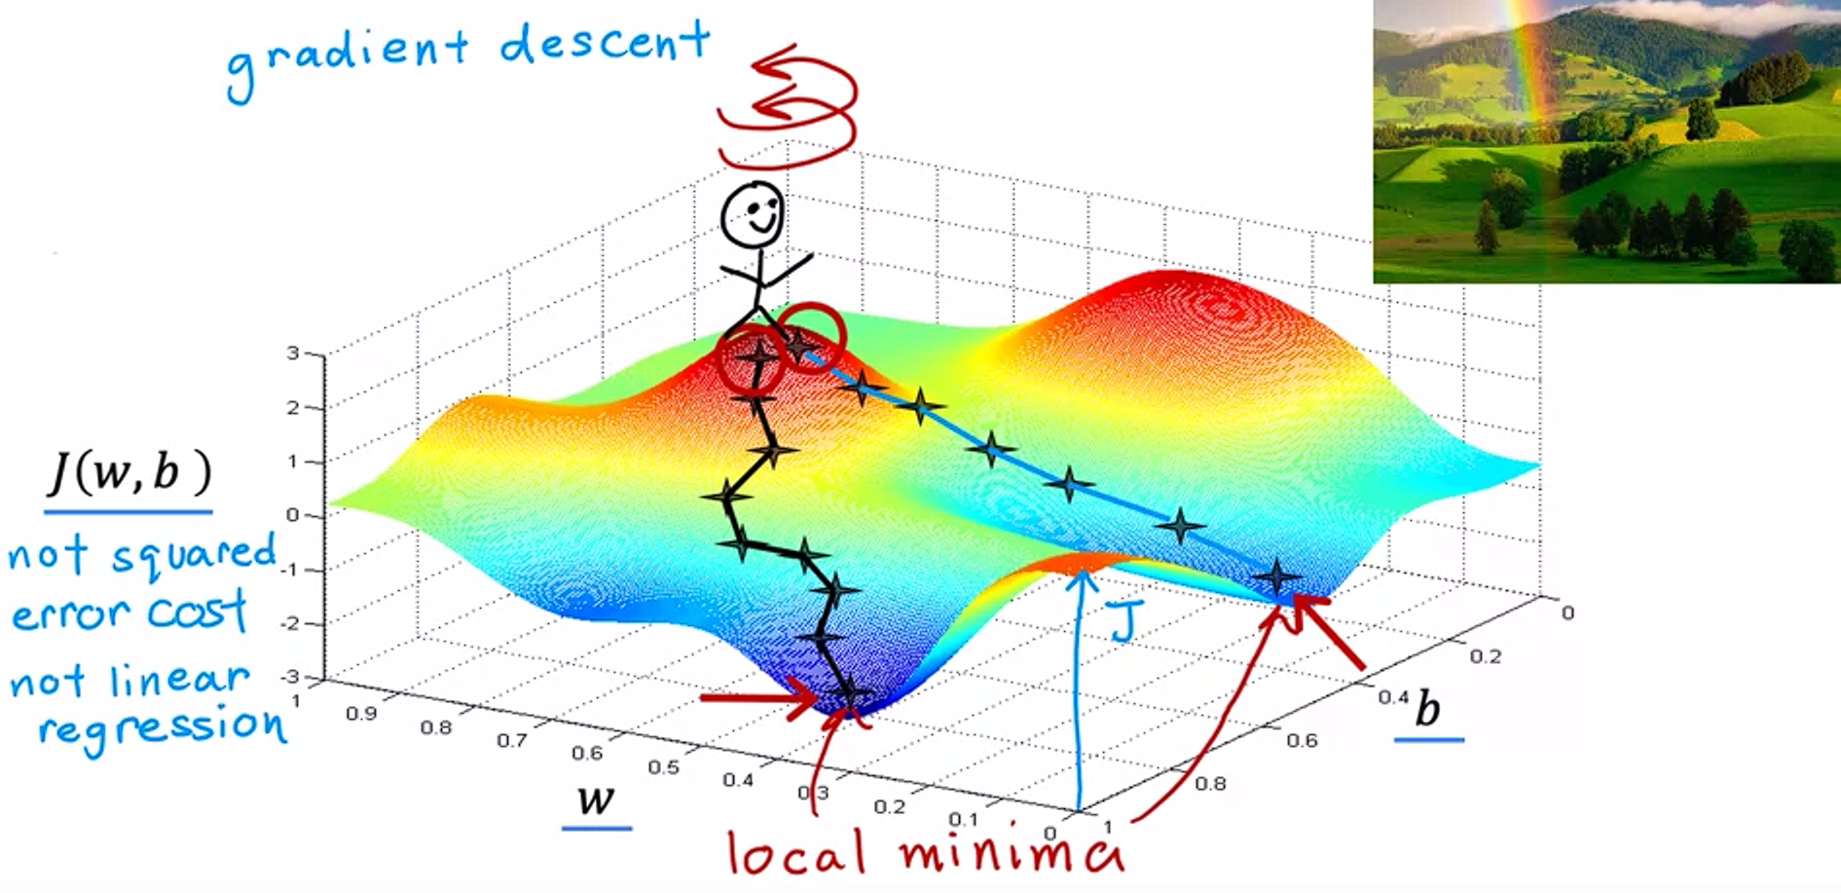

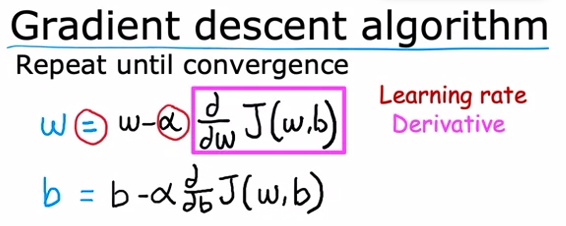

Alpha is learning rate. It is usually some small positive number between 0 and 1.

Both w,b should be updated simultaneously.

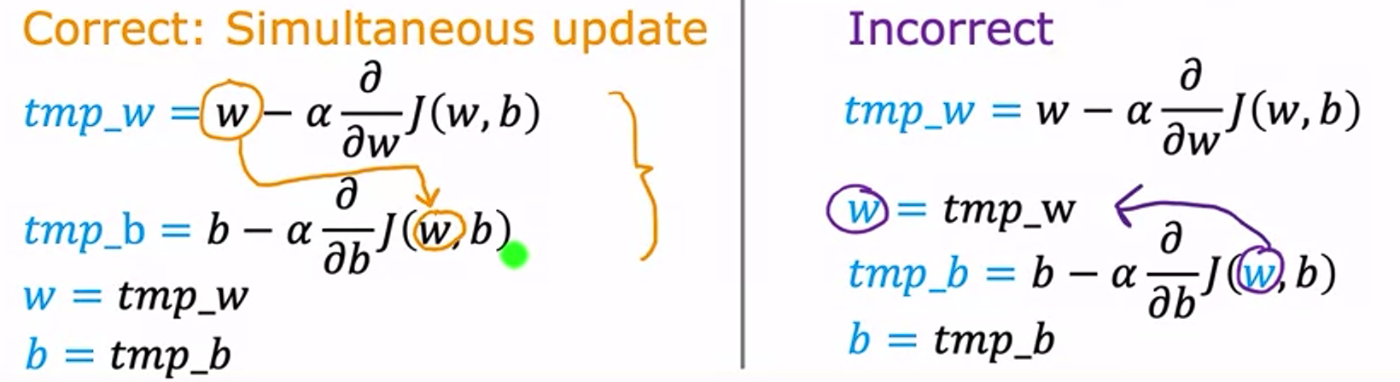

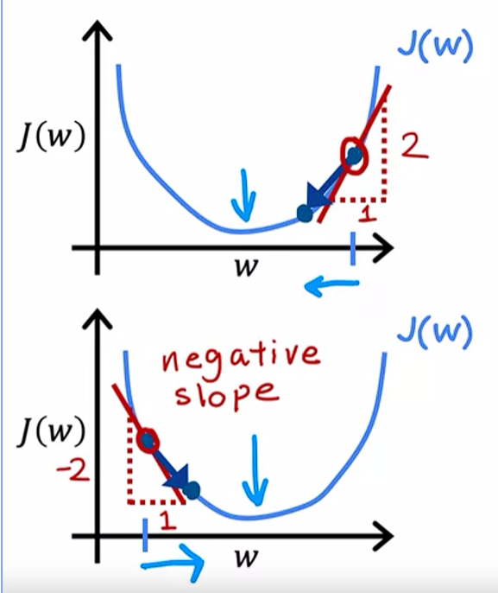

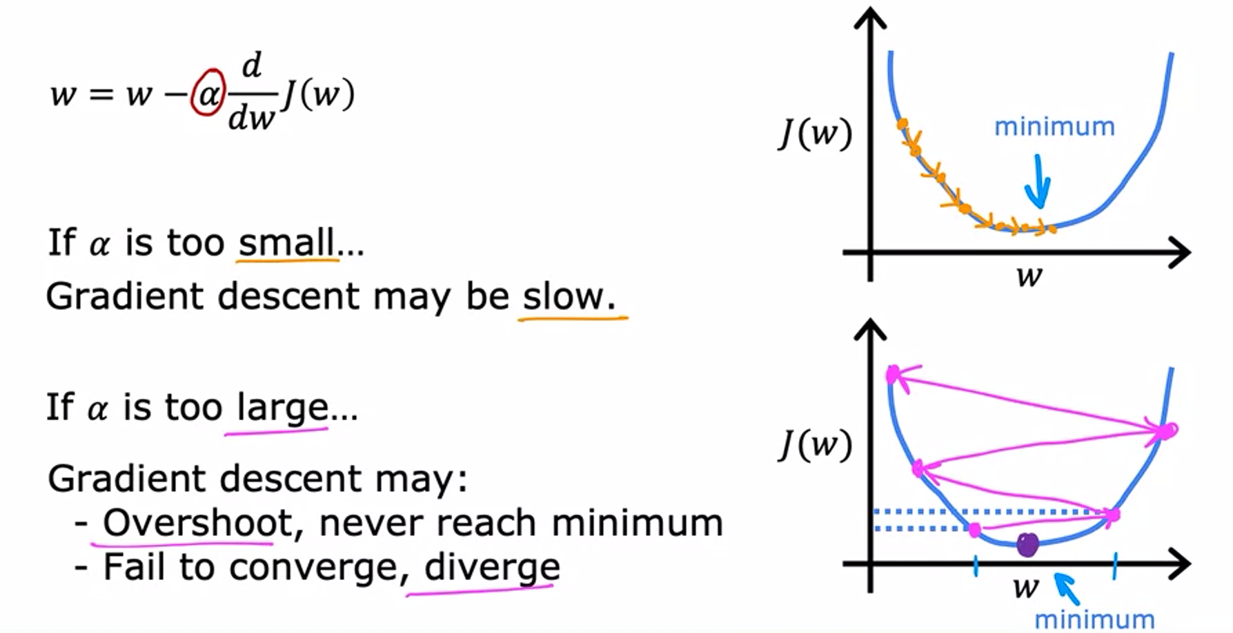

Further iterations of gradient descent do nothing once you reach a local minimum.

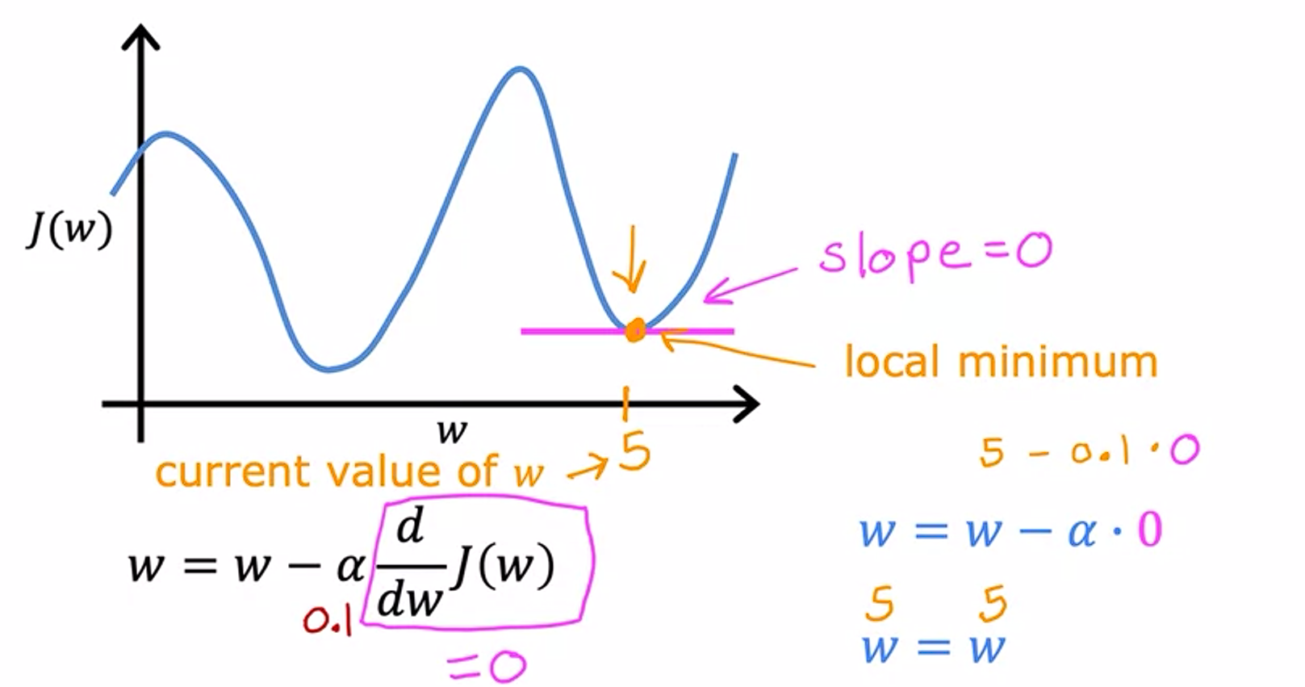

----------------------------------------------------------------------------------------------------------------------------------------------------------------

**Gradient Descent For Linear Regression:**

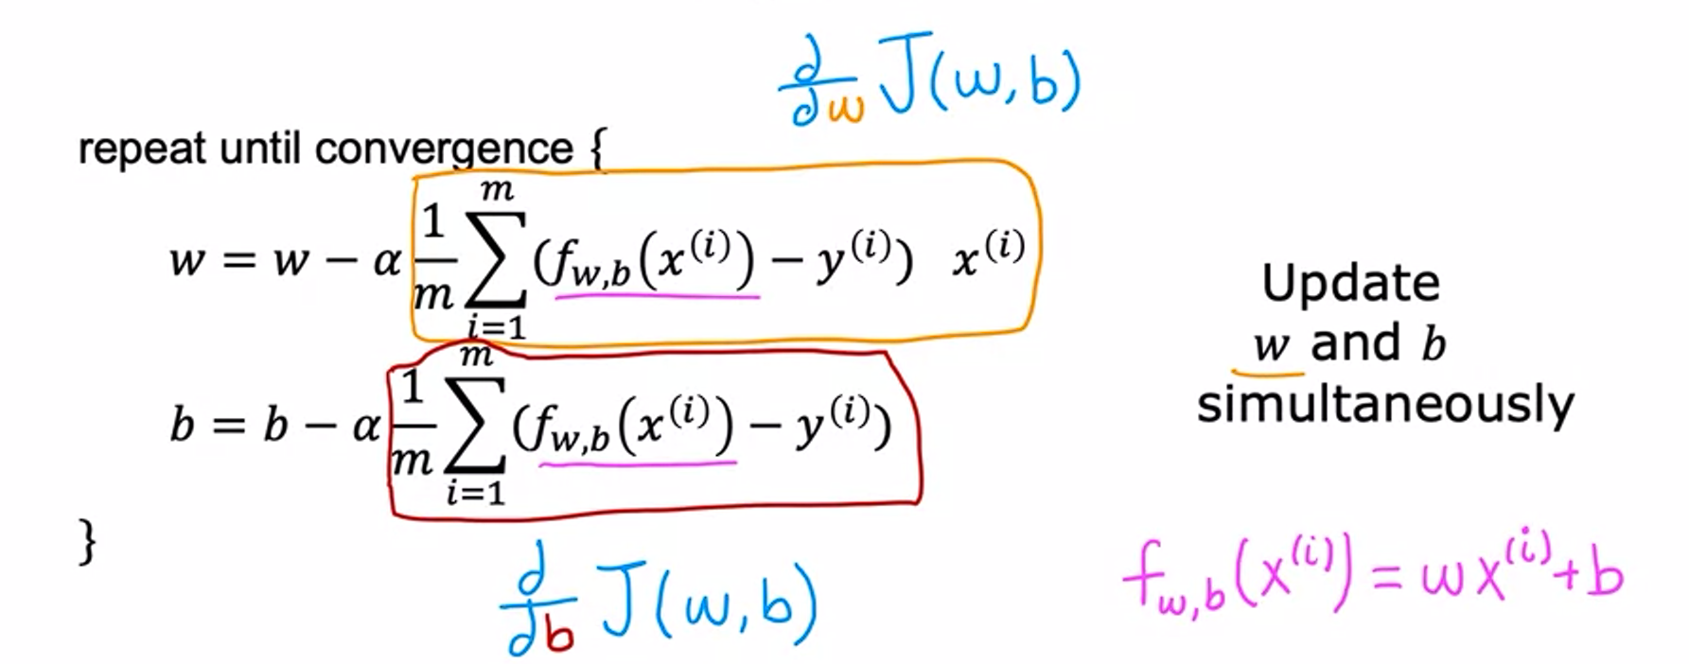

Squared-error cost function with linear regression, the cost function does not and will never have multiple local minima, it just has one global minima, because of its soup-bowl shape. The technical term for this, is that this cost function is a Convex function.

A Convex function is a bowl shaped function which cannot have any local minima other than a single global minima.

**Batch Gradient Descent:**

At each step of the gradient descent, we are looking at ALL of the training examples. (i.e., the cost function iterates over i=1 to m every step, instead of a subset of the training data.)

